**Assessment 1 | DBMS**

1. Consider the following tables structure in Hr Schema and write the following queries :

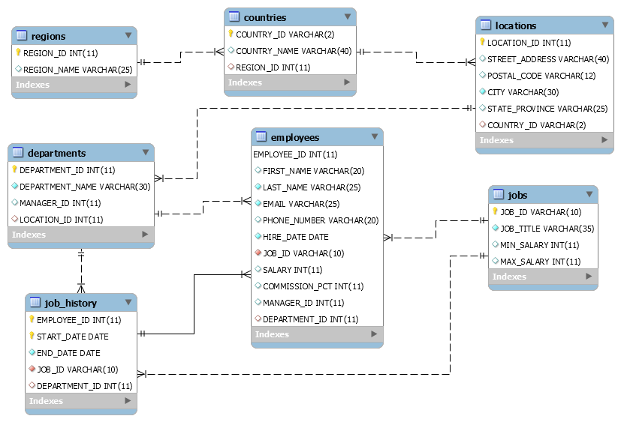

* 1. Write a query for the HR department to produce the addresses of all the departments. Use the LOCATIONS and COUNTRIES tables. Show the location ID, street address, city, state or province, and country in the output. Use a NATURAL JOIN to produce the results.

Soluton:

select l.location_id, l.street_address, l.city, l.state_province, c.country_name

from locations l Natural JOIN countries c;

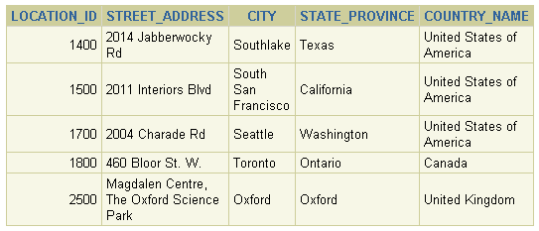

1.2 Create a report to display the last name, job ID, and start date for the employees with the last names of Matos and Taylor. Order the query in ascending order by start date.

Solution:

select last_name, job_id, hire_date

from employees

where last_name IN('Matos','Taylor')

order by hire_date;  
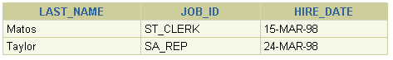

1.3 Create a report to display the last name, salary, and commission of all employees who earn commissions. Sort data in descending order of salary and commissions.

Solution:

select last_name "last name", salary, commission_pct commission

from employees

where commission_pct IS NOT NULL

order by salary desc, commission_pct desc;  
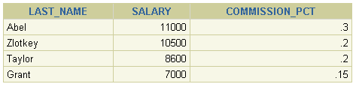

1.4 The HR department needs a report of employees in Toronto. Display the last name, job, department number, and department name for all employees who work in Toronto.

Solution:

select e.last_name,e.job_id,e.department_id,d.department_name

from employees e JOIN departments d

on (e.department_id=d.department_id)

JOIN locations l

on(l.location_id=d.location_id)

where l.city='Toronto';

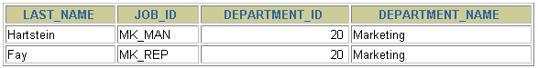

1.5 Determine the number of managers without listing them. Label the column Number of Managers.

Solution:

select sum(count(Distinct manager_id)) as "Managers" from employees

group by manager_id;

